CQF Deep Dive: S&P 500 Sharpe Ratio Optimization

*Cindy Hou, Darren Key, Ben Lorence, Emily Wang*

1. *Abstract*

The central hypothesis is that by choosing weights of companies in the S&P 500 that maximize the Sharpe ratio, alpha will be generated. The dataset comes from the Yahoo Finance API and contains information on the monthly performance of each of the companies in the current S&P 500 between January 2010 to January 2020, most notably, adjusted closing and monthly returns. Although the model produced a Sharpe ratio of 1.18 on the training data, when backtesting, the model produced lower returns than the S&P 500 with total returns of 108 as opposed to S&P returns of 138. We also trained on daily performance of each company in the S&P 500 in the month of January 2020, and also received >1 Sharpe ratio in training, but negligible Sharpe ratio in back testing, although this time with alpha returns compared to the S&P Index. Assets are not normally distributed, an assumption of the Sharpe ratio, so optimizing the Sharpe ratio might not be the best strategy to maximize returns as our backtest has shown.

*2. Preliminary Evidence* 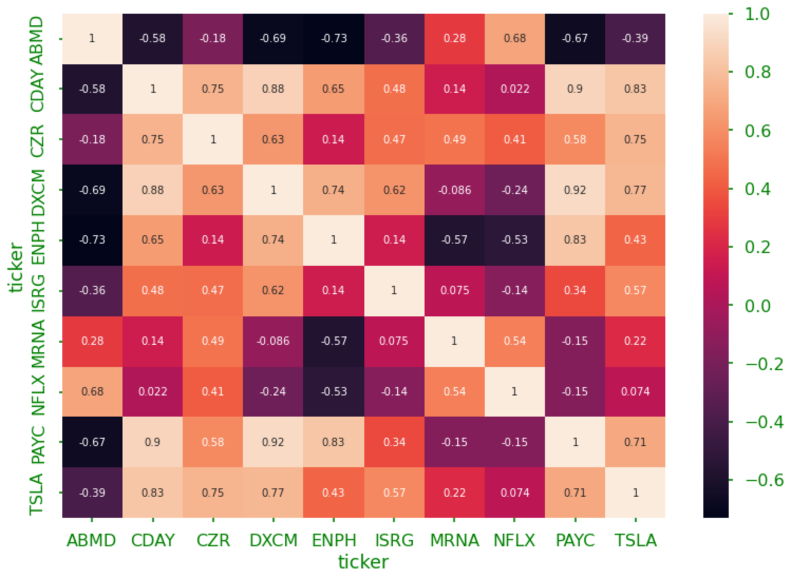

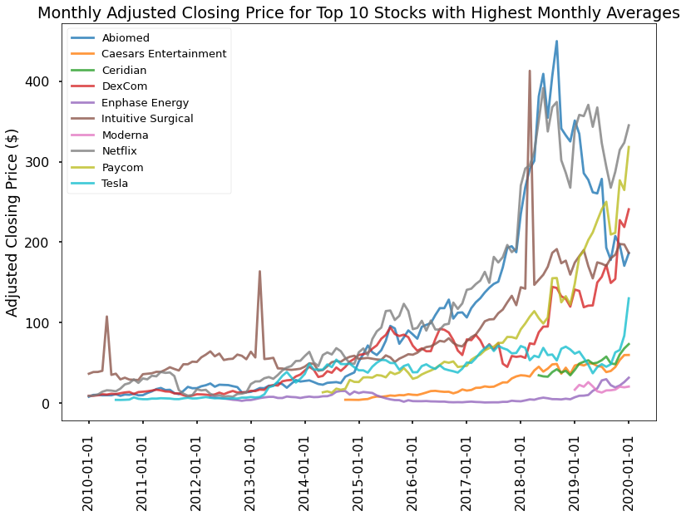

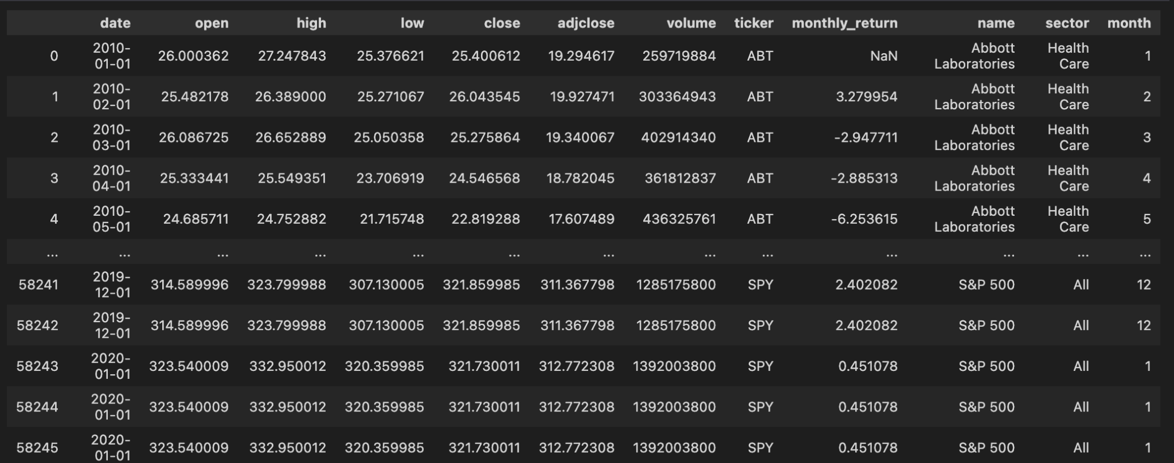

*Yahoo finance data (after processing)*

Our source for the strategy comes from the Markowitz model.

*3. Formal strategy*

We are using a model-based strategy for stocks to calculate the weights to hold of different stocks in the S&P 500 using Sharpe ratio as a metric. The data required is the monthly returns of S&P 500 companies.

*4. Experimental Setup*

a. Data set and size: Originally, we took the data of all the companies listed on the S&P 500, before eventually cutting down on certain ones as our runtime was too long. Companies that would be cut down were often ones that either had little to no volatility in their data along with ones that had not been on the S&P 500 for the entire ten year period.

b. Data quality - The data was taken from Yahoo Finance’s API, which is a reliable source. However, some sources of potential error are that it includes companies from the current-day S&P 500 - some of the companies listed didn’t exist or weren’t currently on the S&P 500 at the time.

c. Backtesting bias precautions: In order to prevent bias in the backtesting, we used the calculated weights from the previous month (January) on the following historical data (February of the same year) in order to check how the total profitability of the results were versus the normal S&P data. In the case of the daily testing, we used the current day’s trained weights on the following trading day, following the assumption that stock prices won’t change a significant degree between smaller time increments.

5. Results

The Sharpe ratio is computed by finding the difference between the average value of the risk-induced returns and the associated risk-free value before then dividing by the standard deviation of the risk returns. We used this to then calculate a final negative sharpe ratio, as minimizing the negative value ultimately maximizes the positive value. Then, we averaged the different sharpe ratios over 120 different tests on the data, leading to a final magnitude of 1.18 for the average ratio. This suggests acceptable performance compared to that of the risk-free returns during training. However, when backtesting, resulting sharpe ratios were positive but negligible, with magnitude around 0.08. These results led us to believe that monthly increments of weights would mean that backtesting with the previous month’s trained weights would be too “outdated,” and thus was the rationale for repeating the experiment with daily data.

Volatility:

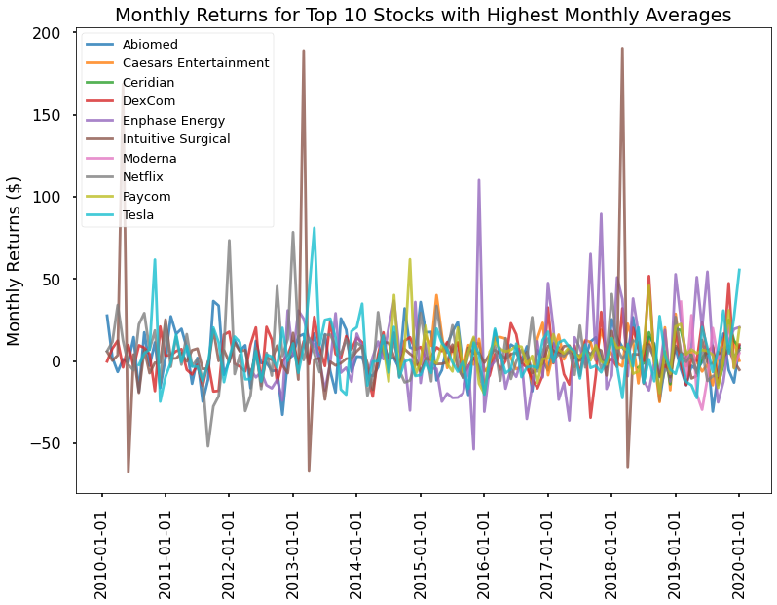

There are large fluctuations in monthly averages, even for the top earning companies

In terms of risk, notably, our dataset was taken pre-COVID. Because our data was taken pre-COVID, from 2010 - 2020, there was only one market regime. We used standard deviation as a measure of risk for each asset, and the Sharpe ratio serves as a way to measure return relative to the risk of an asset.